Scott Nidell

Lab 8 Notes

1000921465

CSE 2441-001

**Introduction:** Lab 8 realizes two finite state machines. One from homework 7 problem 4.51 and another robot control from class discussion. Both machines are to be built and tested prior to the lab session. The first to be realized is the state machine from the homework.

**Theory:**

The first step was to derive a circuit given the logic equations (Figure 1)

**Figure 1:** *Logic equations for the homework FSM*

$$Y1=xy1^{'}y2^{'}+xy1y2+x^{'}y1^{'}y2+x^{'}y1y2^{'}$$

*Which reduces to: $y1=XxorY1xorY2$*

$$Y2=y2'$$

$$Z=y1y2$$

These equations are then put into Quartus to be realized as circuits (Figure 2).

**Figure 2:** *Circuit realization of homework 4.51*

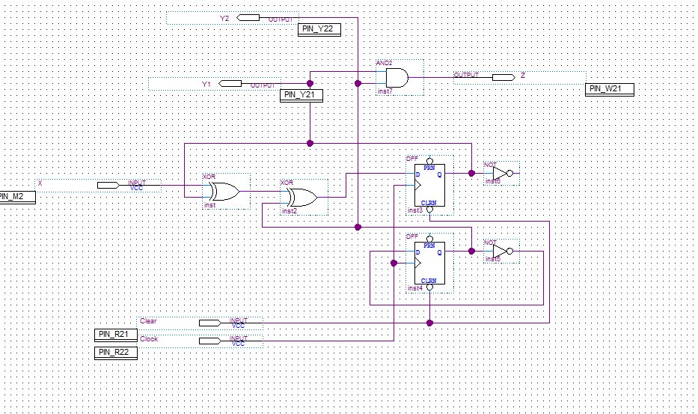

Once the circuit is completed a waveform is generated to verify the design (Figure 3).

**Figure 3:** *Waveform verification of homework problem*

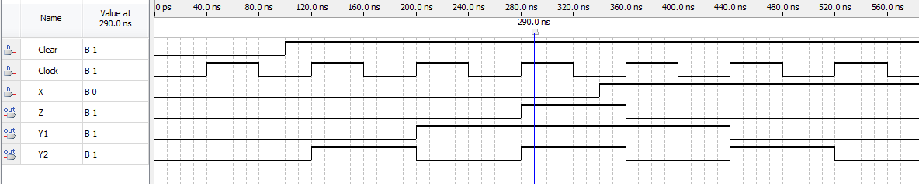

Once the waveform is verified the second part of the pre-lab to realize the robot controller. Using the 10.1 class slides to aid in the design. Using these slides multiple equations for JK flip flops (Figure 4).

**Figure 4:** *Equations for slides problem using JK flip flops*

$$J1=x^{'}y2, K1=x^{'}y2'$$

$$J2=xy1^{'}, K2=xy1$$

These equations are then realized into a circuit using JK flip flops and basic logic gates (Figure 5).

**Figure 5:** *Circuit realization of robot controller*

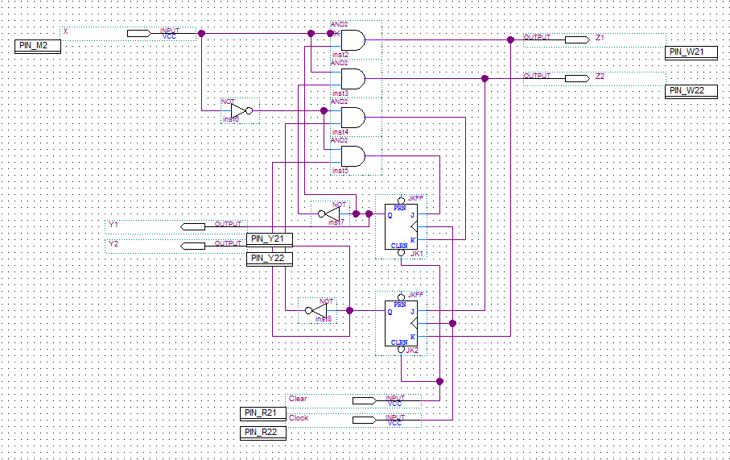

The circuit is now tested to ensure it is accurate. This is accomplished by generating a waveform (Figure 6)

**Figure 6:** *Waveform for robot controller*

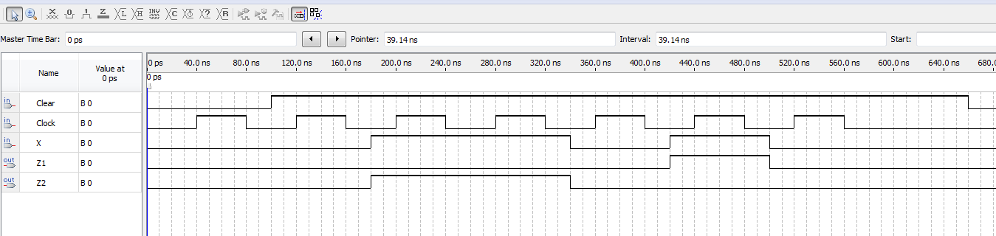

After the pre lab verification the controllers have pins assigned to them using the assignment editor and then programmed onto the DE1 for demonstration. The clock and clear were again assigned to Key 1 and Key 0 along with an input x assigned to Data switch SW7. The functional outputs were assigned to lights to understand how the controller was acting.

**Conclusion:** Since the prelab had all the testing and building out of the way it made for a short and smooth lab period. This lab is useful in the thought that Finite State machines are in almost every control machine. Their uses are endless from robot controllers to counters.